**Interview**

**Why this Position**

**Tell us about yourself**

**My Questions**

* What is the current state of the digital and software program
* A brief overview of current technology portfolio
* Biggest challenges of bringing these to market
* Overview of licensing, startup goals
* Do you see the CS Department as main leader and ways to connect other departments

**About Me**

**Startup Experience**

* MBA
* TacAlert
* 3 Senior Capstones
* Founded Industry Employer Advisory Committee
  + Boeing, Target, HP, United Way
* Instructor

**Finance**

* Conducted financial audit of CDC for Dean of Student Life
  + Worked with UABC

**My Software Knowledge**

**OSU Research**

**Notes**

Research Areas

Data Science and Engineering

Artificial Intelligence and Robotics

Electronic Materials and Devices

Integrated Electronics

Energy Systems

Cybersecurity

Communications and Signal Processing

Networking and Computer Systems

Software Engineering and Human Computer Interaction

Programming Languages

Theoretical Computer Science

Health Engineering

Computer Graphics and Visualization

**Agreements**

To protect information or transfer it appropriately, the **Office for Commercialization and Corporate Development (OCCD)** uses a variety of types of agreements to enter into specific relationships with other entities. Most OSU employees do not have signature authority to sign agreements on behalf of the university. The OCCD has the appropriate authority, and our licensing professionals are experienced in the efficient negotiation and execution of these agreements. Please scroll down to learn more about different types of agreemnts, or [**contact a licensing professional**](mailto:occd@oregonstate.edu) in our office to begin the process.

You may also specifically request a confidentiality or material transfer agreement, by downloading, completing, and emailing one of the following appropriate forms to [**OCCD**](mailto:occd@oregonstate.edu):

[**Confidentiality Agreement Request Form**](http://advantage.oregonstate.edu/sites/advantage.oregonstate.edu/files/non-disclosure_agreement_request_form_vbt20170602jc.docx)

[**Material Transfer Agreement Request Form**](http://advantage.oregonstate.edu/sites/advantage.oregonstate.edu/files/material_transfer_agreement_request_form_vbt20170602jc.docx)

**Primary Agreement Types**

**Confidentiality**

Also known as: Confidential Disclosure Agreement (CDA), Non Disclosure Agreement (NDA), Proprietary Information Agreement (PIA), Confidentiality Transmittal Record (CITR), or Secrecy Agreement. This is a legal document between at least two parties that (a) allows confidential materials, knowledge, or information to be shared with each other for certain purposes, (b) restricts access by others, and (c) maintains it as confidential for a specified time period.

**Material Transfer**

A Material Transfer Agreement (MTA) is a legal document that governs the transfer of tangible research materials between at least two parties, with the recipients intending to use the materials for their own research purposes. The MTA defines the rights of the provider and the recipient with respect to the materials and any derivatives. Biological materials such as reagents, cell lines, plasmids, and vectors are the most frequently transferred materials. MTAs may also be used for other types of materials, such as chemical compounds and even some types of software.

**Industry Research Contract**

Oregon State University generates low-cost, world-class research that is attractive to industry. Collaboration. The win-win advantage helps companies bring products to market faster, generates economic and social benefits, and offers valuable learning opportunities to OSU students. For how it works go to:

[**Standard Model**](http://advantage.oregonstate.edu/sites/advantage.oregonstate.edu/files/occd_brochure_insert_standard_2015jan22.pdf)

[**Alternative Model**](http://advantage.oregonstate.edu/sites/advantage.oregonstate.edu/files/occd_brochure_insert_alternative_2015mar17_3.pdf)

**Option**

 A legal document in which one party pays the other for the exclusive opportunity to review intellectual property and evaluate the marketplace for a specified time period, in a specified field of use with the intention of later executing a license agreement to commercialize an innovation, idea or product.

**License**

A legal document in which one party pays the other for a non-exclusive or exclusive opportunity to commercialize intellectual property and/or know-how, in a specified field of use, for a specified time period, and under specified conditions.

[**Why does OSU license its research?**](http://advantage.oregonstate.edu/sites/advantage.oregonstate.edu/files/occd_brochure_insert_licensing_2015jan22.pdf)

**Other Agreement Types**

**Allocation of Rights**

A legal document accompanying a Small Business Innovation Research (SBIR) award or a Small Business Technology Transfer (STTR) award. The agreement outlines background intellectual property and reserves rights for the award recipient, similar to terms contained in an Option agreement.

**Assignment**

OSU employees are required to sign an Assignment to re-confirm the transfer of all personal property rights provided by a patent, or an undivided fraction of all of the rights as conditioned by employment at OSU. These patent Assignments are recorded with the U.S. Patent and Trademark Office to further protect OSU’s interest in a patent.

**Intellectual Property Management (Proposal)**

Proposals submitted with more than one entity usually require a short section, a long section, or a full separate agreement, regarding the management of intellectual property between the parties. The OTT helps craft these sections acknowledging the needs of industry, the government or other universities, while staying within the parameters of the US laws and OUS/OSU policies.

**Insignia Agreement**

The OSU Licensed Innovation insignia was created to allow authorized users (individuals or companies who have licensed innovation from OSU) to leverage the strong research and technology reputation of Oregon State University in marketing their own products and solutions. The Insignia Program Guidelines provide specifications for the display of the Insignia upon execution of an “OSU Licensed Innovation Insignia Agreement”. OSU may amend the Insignia Specifications from time to time.

**Inter-Institutional**

A legal document governing the protection, administration, and licensing of intellectual property that is jointly owned with another entity. Typically one entity will allow the other to take the lead and to provide a  administrative percentage fee if the intellectual property is successfully licensed.

**Memorandum of Understanding**

Generally a non-binding agreement with another organization that defines the roles, responsibilities, and expectations of each party.

**Royalty Sharing**

An agreement signed by all of the inventors on an invention. It details the distribution percentages for each inventor of the entire  share of royalties that is designated for “the inventor.”

**Sponsored Research**

A legal document between a sponsor and OSU. It provides the details of work, time frame and any of a variety of other specified conditions including intellectual property rights.

**Position Summary**

* Licensing Manager identifies, evaluates, protects, markets and licenses innovations from faculty, staff and students
* Negotiates terms for confidentiality, material transfer, option, license and other IP agreements
* Channels these innovations into market for maximum public benefit
* Support commercialization of a broad spectrum of content, information and communications technology, software and digital assets being developed within the OSU

**Responsible for**

* Management of a portfolio of existing innovations in various stages of evaluation, protection, marketing and licensing

**Ideal Candidate**

* Knowledge of software, content and digital technology space
* Familiarity in software development, computer science of engineering

**Positions Duties**

Software Licensing and Technology Transfer (35%)

* Conduct outreach, develop and manage strong relationships with developers and prospective developers
* Map development activities into potential IP assets, associated deployment strategies and potential target market and acquirers
* Help developers in the identification of key market requirements for current and future content, Software IP by doing market research by visiting customers and non-customers
* Compose and negotiate terms for software licensing agreements, including redistribution and end user agreements
* Help start companies with OCCD and Industry Contracts Associates and Accelerator Program
* Manage a portfolio of ITC content, software and digital technologies
* Manage and monitor existing agreements and relationships with companies and institutions
* Perform periodic analysis of licensees reports with OCCD fiscal manager
* Identify partnerships for the software product portfolio
* Develop programs to expand collaboration with industry partners

IP Protection (10%)

* Coordinate, identify and solicit copyright and invention disclosures from faculty and OSU Employers
* Perform triage to find bars to ownership or commercialization
* Find prior obligations
* Create an IP protection strategy
* Research and prepare IP analysis summaries and direct outside legal counsel on IP prosecutions
* Monitor, manage and review IP filings and adjust strategies as necessary

Marketing Technologies (25%)

* Research and analyze market potential and readiness
* Counsel interns in preparation of market research reports
* Demonstrate ability to maintain strong relationships with faculty developers, inventors, and industry clients
* Compile and analyze technology market data to determine reasonable licensing terms
* Prepare public summaries of technologies, letters, websites and brochures of marketing information

General Service and Other Duties (15%)

* Assist IP and contracts coordinator for iEdision
* Input information to Inteum database
* Attend and represent department for IP Related things Collaborate with OCCD industry contracts Associates and Advantage Accelerator
* Prepare written materis and improve website content

Education (10%)

* Develop annual professional development plan
* Educate faculty
* Answer questions about IP Protection, trademarks, copyrights

Networking (5%)

* Attend trade shows, Meetings and conferences
* Develop and grow business contracts with entrepreneurs and investors

#### What is OSU’s IP-Derived revenue sharing policy?

Oregon State University has one of the most liberal revenue distribution practices in the nation. Following recoupment of expenses, revenue derived from licensing OSU intellectual property is shared based on the following schedule, subject to variation based on OSU’s determination of equities in a given case and MOUs authorized by the President:

|  |  |  |  |
| --- | --- | --- | --- |
| **Net Revenue** | **Inventor** | **College/Unit\***  **(Salary Line)** | **OCCD** |
| 1st $50,000 | 40% | 30% | 30% |
| 2nd $50,000 | 35% | 32.5% | 32.5% |
| $100,000 + | 30% | 35% | 35% |

*Distribution will follow salary support at the time of invention disclosure, which is anticipated to include Colleges, OSU Cascades, and other administrative units on campus.

#### Why might the OCCD decide to not protect an invention? What would that mean to me as the inventor?

The OCCD sometimes decides not to move forward on protecting an invention, if a determination is made that an invention has limited patentability or markets, or if the best path to transfer the invention is determined to be through publication. The OCCD will communicate the decision to the inventors. The inventors may request a waiver from the OCCD to obtain a transfer of rights for the invention. The waiver decision will be dependent on various items such as: the funding source used to develop the invention; the amount of patent and promotional expenses incurred up to the date of the waiver request; and potential future research in the area of innovation.

**Look Up**

Triage procedures- IP

**Required Qualifications**

**Department**

VP for Research

|  |  |
| --- | --- |
| **5-Year Average FY13-FY17** | **FY18 to date** |
| 71 OSU inventions disclosed | 64 OSU inventions disclosed |
| 87 Options/Licenses with existing companies | 69 Options/Licenses with existing companies |
| 7 Options/Licenses with existing companies | 1 Options/License with startup companies |
| 121 Material Transfer Agreements | 122 Material Transfer Agreements |
| 170 Confidentiality Agreements | 158 Confidentiality Agreements |
| 90 Industry Contacts | 57 Industry Contracts |

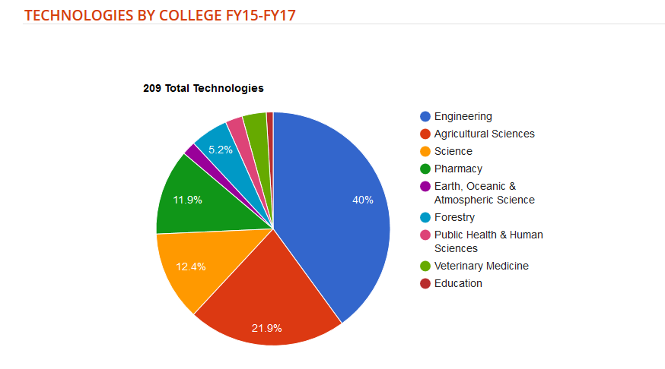

|  |  |  |  |
| --- | --- | --- | --- |
| **Business and Entrepreneurship** | Mentioned | Mentioned | Mentioned |
| MBA |  |  |  |
| TAC Alert |  |  |  |
| RCD Software |  |  |  |
| Venture Accelerator Intern |  |  |  |
| Campus Events |  |  |  |
| Chris Grants and Work |  |  |  |
|  |  |  |  |
| **Love of Software** |  |  |  |
| Y Combinator |  |  |  |
| CS Capstone Sponsor |  |  |  |
| Read through Acquisitions |  |  |  |
|  |  |  |  |
| **My Goals** |  |  |  |
| Create Connections with Portland |  |  |  |
| Create a Software Social Connection |  |  |  |
| Create a Newsletter or Group |  |  |  |
| Slack Group |  |  |  |
| Connect Graphic Design and CS |  |  |  |
| Connect Innovators Across Departments |  |  |  |
| Company that does all the essentials |  |  |  |
| Venture Lab Space |  |  |  |

|  |  |  |  |
| --- | --- | --- | --- |
| **About Me** |  |  |  |
| Love Entpreneurship especially technology |  |  |  |
| Data and metric driven |  |  |  |
| Financial and data audit for Dean |  |  |  |
| MBA |  |  |  |
| MS Thesis- Radiation Detection Software |  |  |  |
| Venture Accelerator Intern |  |  |  |
| 2 years Employer Relations GA |  |  |  |
| 2 Years IT Analyst Student Life |  |  |  |
| Software Development (5 years) |  |  |  |
| OSU Senior Capstone Project Sponsor (3) |  |  |  |
| Always looking for ways to do things better |  |  |  |
| Staff Drive |  |  |  |
| Rebuilt Server Code |  |  |  |